ST10301242
BUSA Part 1
KL Nthunya
Grp 01
Question 1
- Stakeholders involved in the help desk ticket management process
- Customers (end users): Send in support queries and count on prompt, efficient service. Since their satisfaction influences how well services are perceived, they are the main stakeholders (Laudon & Laudon, 2020).
- Customer service representatives are the initial point of contact and are in charge of prioritizing and recording tickets. They are essential to guaranteeing precise data entry and setting priorities (Dumas et al., 2018).
- Agents of technical support: Address tickets that have been assigned. Resolution time and service quality are directly impacted by their experience and workload capacity (IIBA, 2015).
- Senior IT specialist: Manage situations that have escalated and call for specialized knowledge. They guarantee that difficult problems are successfully handled (Harmon, 2019).
- IT service management and leadership should keep an eye on the overall performance of their processes, assign resources, and use performance data to increase productivity (Paul, Cadle, & Yeates, 2014).

- The current “as-is” process workflow, decision points, and interactions
- Ticket Filing: Customers use a web portal, phone, or email to submit support requests.
- Ticket logging: A customer support representative logs the problem into the system and gives a priority level according to its impact and urgency.
- Ticket Assignment: Depending on availability, the system or service agent assigns the ticket to a technical support agent.
- Resolution Attempt: The technical support representative looks into the problem and makes an effort to fix it.
- Decision Point: A senior technician will need to be consulted if the problem calls for specialized knowledge.
- Acceleration Handling: A senior technician examines the problem, uses sophisticated troubleshooting techniques, and makes an effort to resolve it.
- Conclusion and Feedback: The client is informed and the ticket is closed in the system when it has been resolved.
Interactions:
- Customer service representatives communicate with technical personnel as well as clients.
- Cases may be forwarded to Senior Technicians by Technical Agents.
- Although they are not directly involved in ticket flow, management keeps an eye on performance.
A number of decisions must be made during this process, including whether the agent can escalate the problem or handle it on their own. Additionally, there are interactions between technical teams and customer service departments that greatly depend on effective communication (Dumas et al., 2018). Although the "as-is" method shows a standard linear workflow, it also reveals dependencies that could lead to delays (Musenze & Mayende, 2021).
- The current inefficiencies, bottlenecks, and challenges
- Delays in Ticket Resolution: Assigning tickets based on agent availability rather than knowledge is one of the main inefficiencies in the As-Is procedure. Agents may be assigned to problems that are outside of their area of expertise, necessitating reassignments to the proper specialist, which lengthens resolution timeframes. According to Dumas et al. (2018), a significant contributor to workflow inefficiencies is inadequate resource allocation in process management, since duties do not always correspond with personnel competencies. For instance, a general technical support person rather than a database specialist may receive a customer care ticket about a database issue at first. According to Chountalas and Lagodimos (2019), these inefficiencies result from a lack of organized value-chain alignment, where jobs should ideally adhere to rationally defined procedures that correspond with available resources.
- Departmental Miscommunication: Poor departmental communication is another problem with the As-Is method, especially when customer service agents give technical agents erroneous or incomplete information. Because of this, technical professionals frequently have to spend important time obtaining further details before starting their troubleshooting. According to Chang (2016), this issue is linked with a lack of process standardization, which might result in uneven data flow between departments. For instance, a customer might tell a service desk that their "internet is not working," but the technical agent will need to follow up with the customer to get further information if there is no sufficient documentation indicating whether the problem is a network outage, a device malfunction, or a human error. To capture crucial information up front, effective BPM practice recommends using automated logging or structured forms (Chountalas & Lagodimos, 2019).
- Escalation bottlenecks: Escalation bottlenecks happen when senior technicians, who are in charge of managing all complicated difficulties, receive several unsolved cases at once. According to Nayebale (2017), bottlenecks inevitably develop when escalation points are centralized, resulting in backlogs and postponing the resolution of urgent problems. Ten unresolved issues requiring complex configuration changes, for instance, can be routed to a single senior technician in a congested call center setting, making clients wait for hours or even days. Chang (2016) recommends that in order to prevent overloading critical resources, successful BPM should strategically share responsibilities. This might be achieved by implementing intelligent routing systems or tiered escalation structures. In the absence of such redesigns, bottlenecks impair system performance overall by slowing down the resolution process and adding stress to specialist personnel.
- Absence of Automation: The As-Is procedure mostly on human ticket logging and prioritization, both of which are laborious and prone to mistakes. Manual procedures raise the risk of irregular ticket processing, delayed responses, and misclassification. Automation in BPM systems is crucial for guaranteeing process speed, accuracy, and efficiency, claim Dumas et al. (2018). Without automation, for example, two agents can give similar concerns varying priorities, which could result in unjust ticket handling delays. Two clients reporting system outages are an example; if one is manually logged as "low priority" and the other as "critical," the timescales for resolution become erratic. Chang (2016) emphasizes that by guaranteeing uniform execution of business rules, process automation not only lowers human error but also creates avenues for quality improvement.
- Inconsistent Service Quality: Disparate technicians may use different troubleshooting techniques, which makes service delivery less consistent (Musenze & Mayende, 2021).
The following are the main causes:
- Inefficient resource allocation (skill-based vs. availability-based);
- Inadequate protocols for communication between technicians and service agents;
- An excessive reliance on senior technicians, which restricts scalability;
- The lack of real-time tracking and automation technologies.

- The 5 Key Performance Indicators
To measure process effectiveness, the following KPIs are recommended:
- The average time from ticket submission to closure is measured by the Average Ticket Resolution Time. shows how well resources are being used.

- The percentage of tickets that are resolved without escalation is known as the First Contact Resolution Rate. demonstrates personnel proficiency and service quality (Joppen et al., 2019).

- The frequency with which tickets are forwarded to senior technicians is measured by the ticket escalation rate. High rates suggest deficiencies in training or skills.

- Feedback gathered after a resolution is used to calculate the Customer Satisfaction Score (CSAT), which gauges how satisfied customers are with the service.

- Agent Utilization Rate: Evaluates resource optimization by distributing workload among technical support personnel (Harmon, 2019).

- Every KPI is quantifiable, pertinent, and actionable, giving management information about performance and areas in need of ongoing development (Saranya & Anithaashri, 2020).
Question 2
- The As-Is BPMN diagram presenting help desk ticket management process
The support desk ticket management process's present workflow is depicted in the As-Is BPMN diagram, which emphasizes how jobs are allocated and carried out without optimization. The client starts the process in the current configuration by reporting a problem online, over the phone, or by email. After that, the customer support representative manually enters the ticket into the system and assigns a priority. A technical support agent then receives the issue and starts troubleshooting. There will be further delays, though, as the problem must be referred to a senior technician if it turns out to be too complicated. According to von Rosing et al. (2015), BPMN offers a standardized method for representing these activities through tasks, flows, and gateways, guaranteeing that stakeholders are aware of their roles and the points at which decisions are made in the workflow.
The Structure of the “As-Is” Diagram:
- Client
- Customer Service Agent
- Technical Support Agent
- Senior Technician

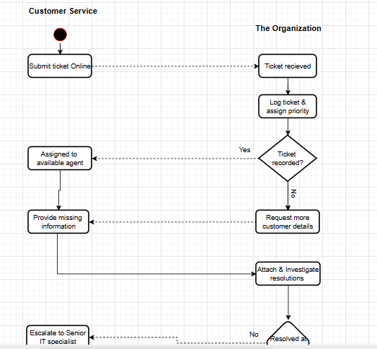

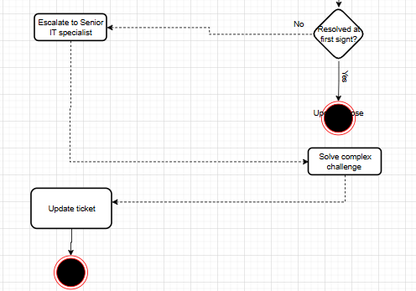

Inefficiencies that can have a detrimental impact on customer satisfaction and response time, like manual ticket logging and delayed communication during escalation, are highlighted in the As-Is diagram. Since As-Is models offer a starting point for process improvement projects, Fossland and Krogstie (2015) stress that they are essential for comprehending the existing pain spots prior to attempting any redesign. It is evident from examining the As-Is BPMN diagram that the absence of automation and real-time tracking leads to poor accountability, longer resolution times, and decreased visibility for support teams and clients alike. According to Asllani (2024), recording the existing situation is crucial for both identifying flaws and establishing a methodical framework for the To-Be process model. The As-Is BPMN diagram is therefore a useful tool for graphically outlining the current inefficiencies that require attention.

The enhanced process following re-engineering and automation is depicted in the To-Be BPMN diagram. In contrast to the As-Is approach, the system now automatically logs requests and classifies them according to pre-established business rules like urgency or issue category. In this future state, clients still start the process by submitting tickets. According to Von Rosing et al. (2015), this lowers human error and manual labour. They also point out that BPMN's standardized symbols provide better clarity when modelling altered processes. After that, tickets are automatically forwarded to the best technical support representative, guaranteeing a quicker response and cutting down on needless escalations. The technology expedites resolution by forwarding the case to a senior technician along with a thorough log of prior troubleshooting efforts if escalation is required. This improved workflow improves client experience while increasing accountability, efficiency, and transparency.

Structure of the “To-Be” Diagram (Improvements):
  - Client
  - Customer Service Agent
  - Automated Ticket Routing System (new participant)
  - Technical Support Agent
  - Senior Technician
  - Management (active in To-Be)

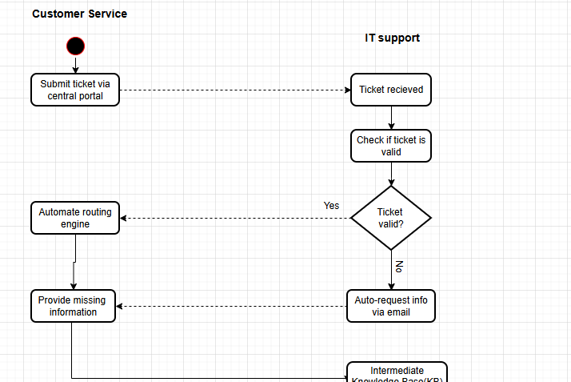
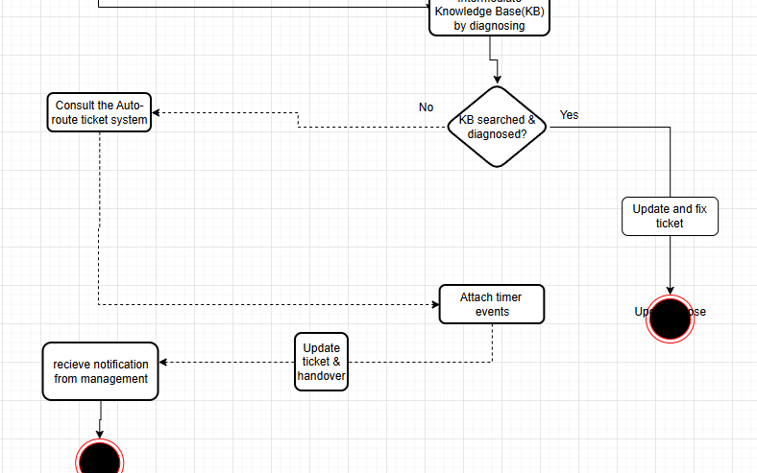

Utilizing automation and decision-support tools, the To-Be diagram illustrates how BPMN may facilitate digital transformation. To-Be modeling is a forward-looking technique that matches future business procedures with technical capabilities, allowing businesses to address flaws found in the As-Is model, according to Fossland and Krogstie (2015). In a similar vein, Asllani (2024) emphasizes the importance of incorporating intelligent systems into BPMN to guarantee real-time process validation and monitoring, which lowers turnaround times and improves service quality. The To-Be method lowers inefficiencies and establishes a scalable framework for ongoing improvement by putting such innovations into practice. In the end, the revised BPMN diagram shows how an efficient workflow may improve client happiness, increase responsibility, and cut down on delays, making it a strategic instrument for business success.
Question 3
Question 2
- Specific improvements during the To-Be design process
In order to solve the shortcomings found in the As-Is BPMN diagram, the To-Be design process included a number of systematic changes. The automation of ticket logging and classification was one of the biggest improvements. Customer care representatives manually recorded issues in the As-Is method, which raised the possibility of human error and delays. By enabling the system to automatically record the ticket and assign categories like urgency, issue kind, and service level, the To-Be model re-engineered this. BPMN makes it easier to leverage automation and decision gateways to cut down on pointless manual processes and standardize intricate procedures (Von Rosing et al., 2015). Faster ticket registration, consistent classification, and more effective routing to the appropriate support team are all guaranteed by this enhancement.
The automatic assignment and escalation process was another significant enhancement. Customer support representatives used to have to manually assign tickets to technical agents and forward unresolved problems to senior technicians. According to the To-Be model, unresolved cases are escalated immediately with a thorough log of previous troubleshooting attempts, while tickets are automatically routed to agents with the appropriate competence. To-Be designs should make use of existing technology to reduce needless reliance on humans while maintaining workflow transparency, according to Fossland and Krogstie (2015). This improvement guarantees that escalated issues reach the appropriate expert in a quicker amount of time, decreases downtime, and improves responsibility.
The To-Be process also includes client upgrades and real-time notifications. Client satisfaction was lowered in the As-Is stage since they were frequently kept in the dark until a remedy was offered. Clients may now see the status of their requests thanks to the enhanced design's automatic progress alerts. According to Mariya et al. (2024), by guaranteeing effective information flow, BPMN promotes cooperation not just between employees but also between businesses and their clients. In addition to increasing consumer trust, this enhancement brings service delivery into line with contemporary standards for transparency. When taken as a whole, these particular enhancements show a purposeful reorganization of the workflow to improve accuracy, speed, and accountability.

- Justification of design choices with reference to BPMN best practices
The To-Be BPMN diagram's design decisions are based on BPMN best practices, which prioritize efficiency, simplicity, and clarity in process representation. The fact that BPMN offers defined notations such service tasks, gateways, and events that clearly illustrate automated workflows is one of the most significant arguments for automation in the To-Be design (Von Rosing et al., 2015). The To-Be model uses automation gateways to assign tasks and handle escalations rather than depending on human participation at every stage. This is consistent with BPMN recommended practices, which advocate avoiding manual bottlenecks to cut down on needless complexity (Asllani, 2024).
The process's openness and communication provide yet another defence. Clear event-based flows are recommended by BPMN best practices as a way to enhance communication between many players (Mariya et al., 2024). To ensure that stakeholders are informed at every level, the To-Be design uses message events to illustrate the introduction of real-time client alerts. In line with the idea that both business users and IT specialists should comprehend BPMN, this enhances cooperation between technical and non-technical players (Fossland & Krogstie, 2015). Moreover, the methodical ticket routing through decision gateways shows compliance with BPMN's advice to graphically represent business rules rather than relying on human judgment or leaving them implicit.
Lastly, the To-Be design's incorporation of escalation mechanisms adheres to BPMN best practices for handling exceptions. Kasim and Haracic (2018) state that well-modelled processes ought to include procedures for handling problems that don't follow conventional procedure, including complicated tickets that call for the assistance of a senior technician. By automatically transferring unresolved instances with complete historical data, the To-Be model incorporates this, reducing rework and adhering to BPMN's efficiency principle through appropriate exception handling. Together, these decisions show how the revised process balances automation, exception handling, and clarity in accordance with BPMN best practices.
- Expected benefits of the improved design
Significant gains in productivity, client happiness, and resource use are anticipated from the To-Be design. Automation of ticket logging and classification reduces unnecessary human procedures and speeds up response times from an efficiency standpoint. This is consistent with research by Kasim and Haracic (2018), who contend that by optimizing workflows and cutting down on operational waste, BPM can increase business efficiency. By eliminating the delays brought on by manual allocation, automatic routing guarantees that technical concerns are promptly forwarded to the appropriate agent. Real-time updates also cut down on pointless back-and-forth correspondence between customers and customer support representatives, which expedites the resolution process even more.
The enhanced design has a significant effect on consumer satisfaction. Automatic progress notifications and regular updates provide clients more insight into the process, which lessens their frustration and confusion. Customer satisfaction is attained when both explicit and implicit requirements are successfully met, claim Poornachandrika et al. (2020). The To-Be model accomplishes this by making sure that clients feel informed and appreciated at every stage of the process, in addition to making sure that problems are promptly remedied. Additionally, by keeping cases from stalling, the methodical escalation mechanism guarantees that complicated issues get professional attention quickly. Customers will have a more dependable and consistent experience as a result, which immediately increases loyalty and trust.
In order to address this, the To-Be process makes sure that technical agents only work on activities that fall within their areas of expertise, with the system handling routing and classification. According to von Rosing et al. (2015), the structured approach of BPMN guarantees more efficient resource allocation, hence optimizing productivity. Furthermore, BPMN diagrams improve team cooperation by defining roles and minimizing overlap, which results in more effective workforce utilization, according to Mariya et al. (2024). This reduces expenses related to rework and delays while also optimizing human resources. Long-term, the enhanced design supports scalability and agility as the company expands by laying the groundwork for ongoing process improvement.
Reference List
- Asllani, A., 2024. Artificial intelligence for generation and verification of UML and BPMN diagrams. [pdf] polito.it. Available at: https://webthesis.biblio.polito.it [Accessed 29 August 2025].
- Chang, J.F., 2016. Business process management systems: strategy and implementation. 2nd ed. Boca Raton: Taylor & Francis.
- Chountalas, P.T. and Lagodimos, A.G., 2019. Paradigms in business process management specifications: a critical overview. Business Process Management Journal, 25(2), pp.305–323. Available at: https://www.academia.edu [Accessed 29 August 2025].
- Dumas, M., La Rosa, M., Mendling, J. and Reijers, H.A., 2018. Fundamentals of Business Process Management. 2nd ed. Springer.
- Musenze, I.A. and Mayende, T.S., 2021. Inconsistent service quality in IT service management: a business process management perspective. African Journal of Business Management, 15(3), pp.87–96.
- Nayebale, D., 2017. Escalation bottlenecks in IT service operations: an analysis of service desk performance. International Journal of Information Systems and Project Management, 5(2), pp.53–66.
- Fossland, S. and Krogstie, J., 2015. Modeling as-is, ought-to-be and to-be-experiences from a case study in the health sector. [pdf] academia.edu. Available at: https://www.academia.edu [Accessed 29 August 2025].
- Kasim, T., Haracic, M. and Haracic, M., 2018. The improvement of business efficiency through business process management. [pdf] econstor.eu. Available at: https://www.econstor.eu [Accessed 29 August 2025].
- Mariya, K., Sofiia, Z., Ganna, W. and Kateryna, M., 2024. BPMN Diagrams as an Essential Tool for Enhancing Business Process Management and Team Collaboration. [pdf] ersj.eu. Available at: https://ersj.eu [Accessed 29 August 2025].
- Poornachandrika, V., et al., 2020. Quality transformation to improve customer satisfaction: using product, process, system and behaviour model. [pdf] iop.org. Available at: https://iopscience.iop.org [Accessed 29 August 2025].
- Dumas, M., La Rosa, M., Mendling, J. and Reijers, H.A., 2018. Fundamentals of Business Process Management. 2nd ed. Springer. [Accessed 11 Aug 2025]
- Harmon, P., 2019. Business Process Change: A Business Process Management Guide for Managers and Process Professionals. 4th ed. Morgan Kaufmann.
- Joppen, R., von Enzberg, S., Gundlach, J. and Kühn, A., 2019. Key performance indicators in the production of the future. Procedia CIRP, 79, pp.678–683. Elsevier. Available at: https://www.sciencedirect.com/... [Accessed 24 Aug. 2025].
- Musenze, I.A. and Mayende, T.S., 2021. Coordination and quality service delivery in service organizations: Qualitative investigation. Journal of African Business, 22(4), pp.475–493. Taylor & Francis. Available at: https://www.researchgate.net/publication/... [Accessed 11 Aug. 2025].
- Nayebale, A., 2017. Examining the causes and effects of communication on service delivery: A case study of Jinja District Local Government. Kampala International University Institutional Repository. Available at: https://ir.kiu.ac.ug/handle/... [Accessed 30 July. 2025].
- Laudon, K.C. and Laudon, J.P., 2020. Management Information Systems: Managing the Digital Firm. 16th ed. Pearson. [Accessed 26 Aug 2025]
- Laudon, K.C. & Laudon, J.P. (2022) Management Information Systems: Managing the Digital Firm. 17th edn. Harlow: Pearson.
- Peppard, J. & Ward, J. (2016) The Strategic Management of Information Systems: Building a Digital Strategy. 4th edn. Chichester: Wiley. [Accessed 26 Aug 2025]
- Saranya, M. and Anithaashri, T.P., 2020. Novel approach to enhance network security using key performance indicator in business analytics. IOP Conference Series: Materials Science and Engineering, 993, 012052. Available at: https://iopscience.iop.org/... [Accessed 12 Aug 2025]
- Von Rosing, M., White, S., Cummins, F. and De Man, H., 2015. Business Process Model and Notation (BPMN). [pdf] omg.org. Available at: https://www.omg.org [Accessed 29 August 2025].

